6. You have an algorithm that process a list of numbers. It firsts sorts the list using an
efficient sorting algorithm and then finds the maximum element in sorted list. Write the
code for the same.
Test Cases

7. Empty List

8. Input: []

9. Expected Output: None or an appropriate message indicating that the list
is empty.

10. Single Element List

11. Input: [5]

12. Expected Output: 5

13. All Elements are the Same

14. Input: [3, 3, 3, 3, 3]

15. Expected Output: 3

PYTHON CODE:
n = int(input("Enter number of elements: "))

arr = []

if n == 0:
print("List is empty")
else:
print("Enter the elements:")
for i in range(n):
arr.append(int(input()))

arr.sort()

print("Sorted List:", arr)
print("Maximum Element:", arr[-1])

Sample Output 1 (Empty List)
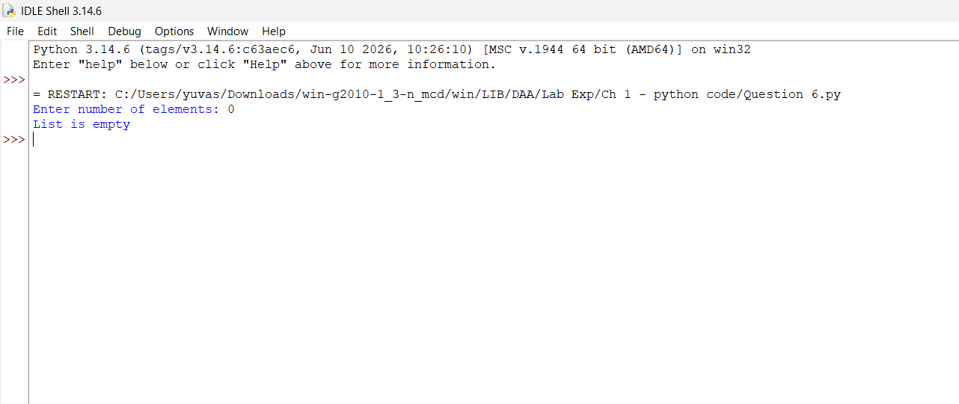

Sample Output 2 (Single Element)
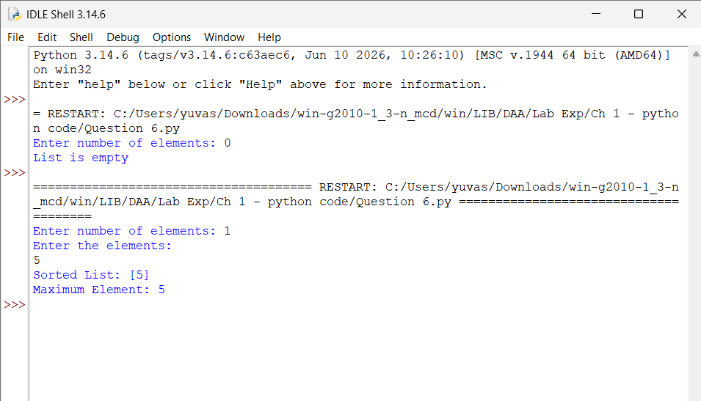
Sample Output 3 (All Elements Same)
